Foundation Year Project Report

Computer Science

Group K

Created by:

Salman Ashraf

Engin Gedik

Jamie Li

Aadil Sarwar

Martine Shams

Contents

1.1 Introduction 3

1.2 Influence of the website on the design 3

1.3 Influence of the website on technologies used 3

2.1 The structure of the website 4

2.2 Navigation 8

2.2.1 Navigation From Landing Page 8

2.2.2 The top navigation bar (and footer) 8

2.2.3 Navigation to External Sites 9

2.3 Visuals and information 10

2.3.1 Visuals used 10

2.3.2 Information used 10

3.1 How does it work 11

3.1.1 Landing page 11

3.1.2 Manchester, UoM, Student life, FY 12

3.1.3 About Us 13

3.2 Tech used during creation 13

3.2.1 Creation process 13

3.2.2 Programming 15

3.3 Creation process 15

3.3.1 Pre-creation of site 15

3.3.2 Early creation stages 15

3.3.3 Main creation phase 16

3.3.4 Final stages 16

4.1 Main conclusion 17

4.1.1 Website brief 17

4.1.2 Website – Design aspect 17

4.1.3 Website – Technical aspect 17

4.2 Reflections 17

4.2.1 Engin G. reflection 17

4.2.2 Aadil S. reflection 17

4.2.3 Jamie L. reflection 18

4.2.4 Martine S. reflection 18

4.2.5 Salman A. reflection 18

4.2.6 Group reflection 18

4.3 Main things learnt as a group 19

1 Website Brief

# Introduction

This website’s purpose is to provide key information that we feel is essential to know before starting a Computer Science Foundation Year in the University of Manchester, and the relevant experiences each of the group members has had. We hope that this can serve as a guide to help future and current students with their experiences and make the most of their time at Manchester and their course.

# Influence of the website on the design

The website’s purpose is to provide information on the key aspects of life at the University of Manchester as a Foundation Year student. This allowed for the website to be divided into multiple segments

* Introduction – The main landing page that doubles as a context
* City of Manchester – Information about the heritage of the city
* University of Manchester – The facilities that are available and career opportunities
* Foundation Year – Summary of course content and progression
* Student Life – The life as a student and what you can do outside of lectures
* About Us – Our short biographies

This allowed each tab to be designed around it’s respective topic. We delegated the topics to each group member based on their own experiences in said topic.

# Influence of the website on technologies used

The website was created using HTML5, and CSS3.

* This was only influenced by the task, which was to create a website

The code editor of choice for the entire group was Visual Studio Code (VS Code).

* It was the code editor the group had most familiarity with, alongside it being easy to integrate with GitHub
* Extensions from the VS Code marketplace were employed as well, including but not limited to:
  + Prettier – Prettier
  + vscode-pdf – tomoki 1207
  + Live Server – Ritwick Dey
  + Image Preview – Kiss Tamas
  + Color Highlight – Sergii Naumov
  + Auto Rename Tag – Jun Han

Version control, backing up and synchronising was done by integrating GitHub to VS Code.

* GitHub was selected for this purpose due to one of the group members being comfortable using it, which allowed for the group’s work to be always synchronised and available to all members without clashing documents.

In terms of the influence of the website on technologies used, there is no significant influence, but the technologies were selected based on the group’s familiarity with them, and if they made it easier to create the website.

As a side note, whilst creating the report, PicPick was a very beneficial tool to use, as it allowed for the capture of rolling screenshots, which allowed entire pages to be taken as a screenshot and preserve the appearance of the site

1. Website – Design Aspect

# The structure of the website

There are 4 distinct styles that can be found within the website. The “Home” page has its own unique style that is dedicated to help with initial navigation. The “Manchester”, “UOM” and “Student Life” are styled to allow multiple images with text to help readers understand the foundation year experience. “FY” is more information heavy than the other categories due to the extensive nature of the course. The “About Us” section is designed to allow insight into the team members, hence why there is more emphasis placed on the balance between images and text.

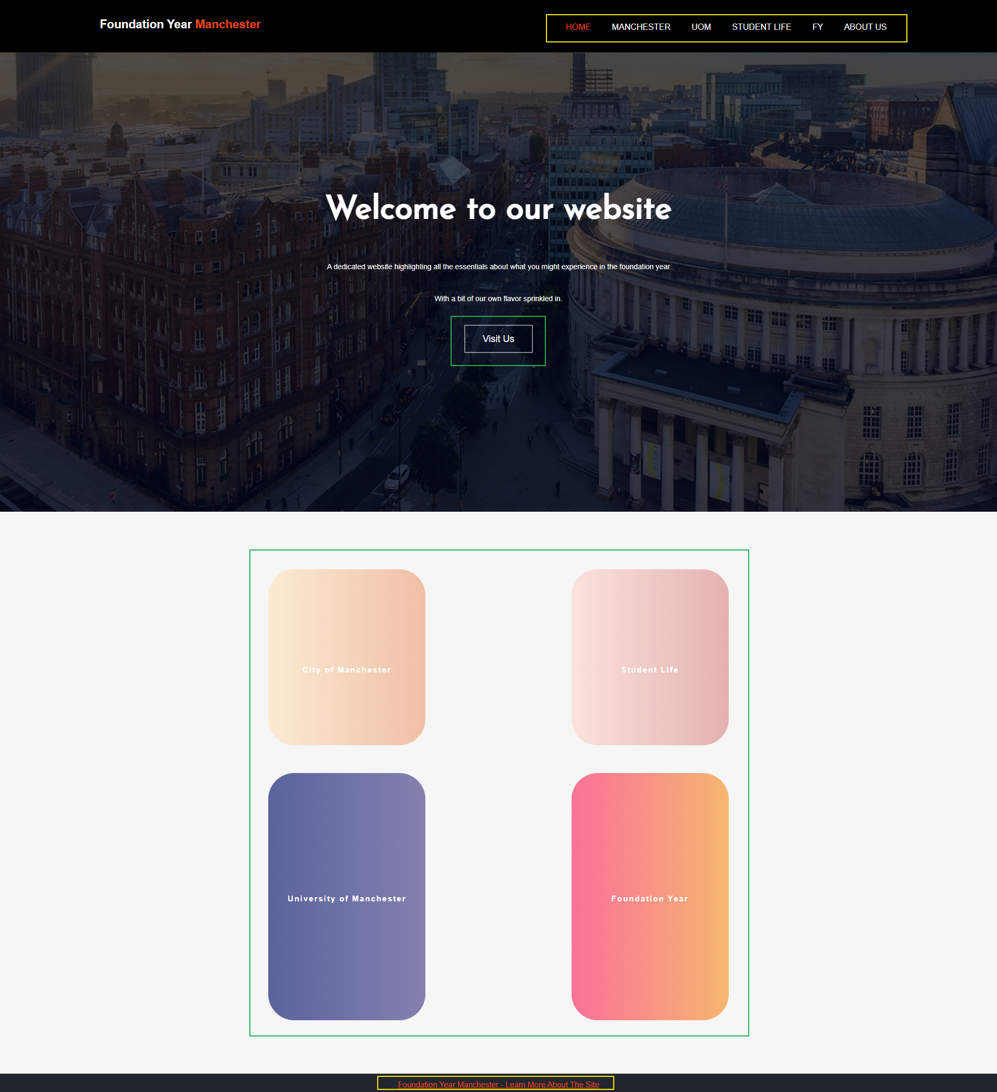

Figure : main landing page

Figure 1’s design is based around helping navigation and providing easy access to the different areas within the website. The distinct lack of images and text is to contain the attention of viewers on either the top navigation bar or the bubbles to use as navigation.

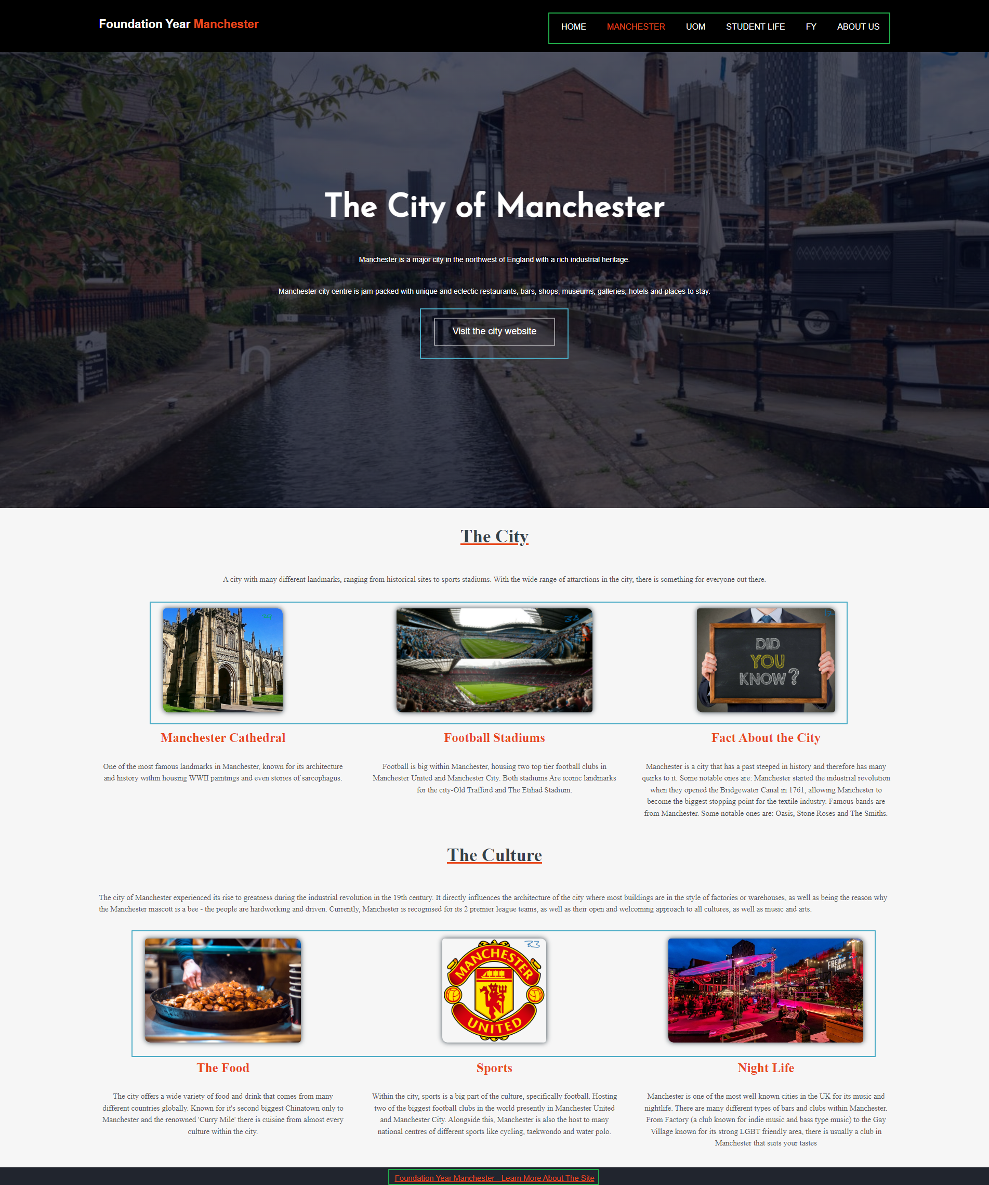s

Figure : Manchester section of the website with highlights

The design of the Manchester section of the site is designed to provide concise information regarding its respective topics.

The page is divided into 3 sections, the main loading page, with the “The City of Manchester” text and banner, the first information segment – “The City” and the second information segment – “The Culture”.

These contain subtitles and subtexts to engage the readers and provide an overview into the respective sections of Manchester.

Images contained within the blue boxes in Figure 2 are used to navigate into external sites that will provide information regarding the text it is associated with.

Like the other pages, the top navigation bar and footer, boxed in green, can be used to access the other sections and the GitHub repository.

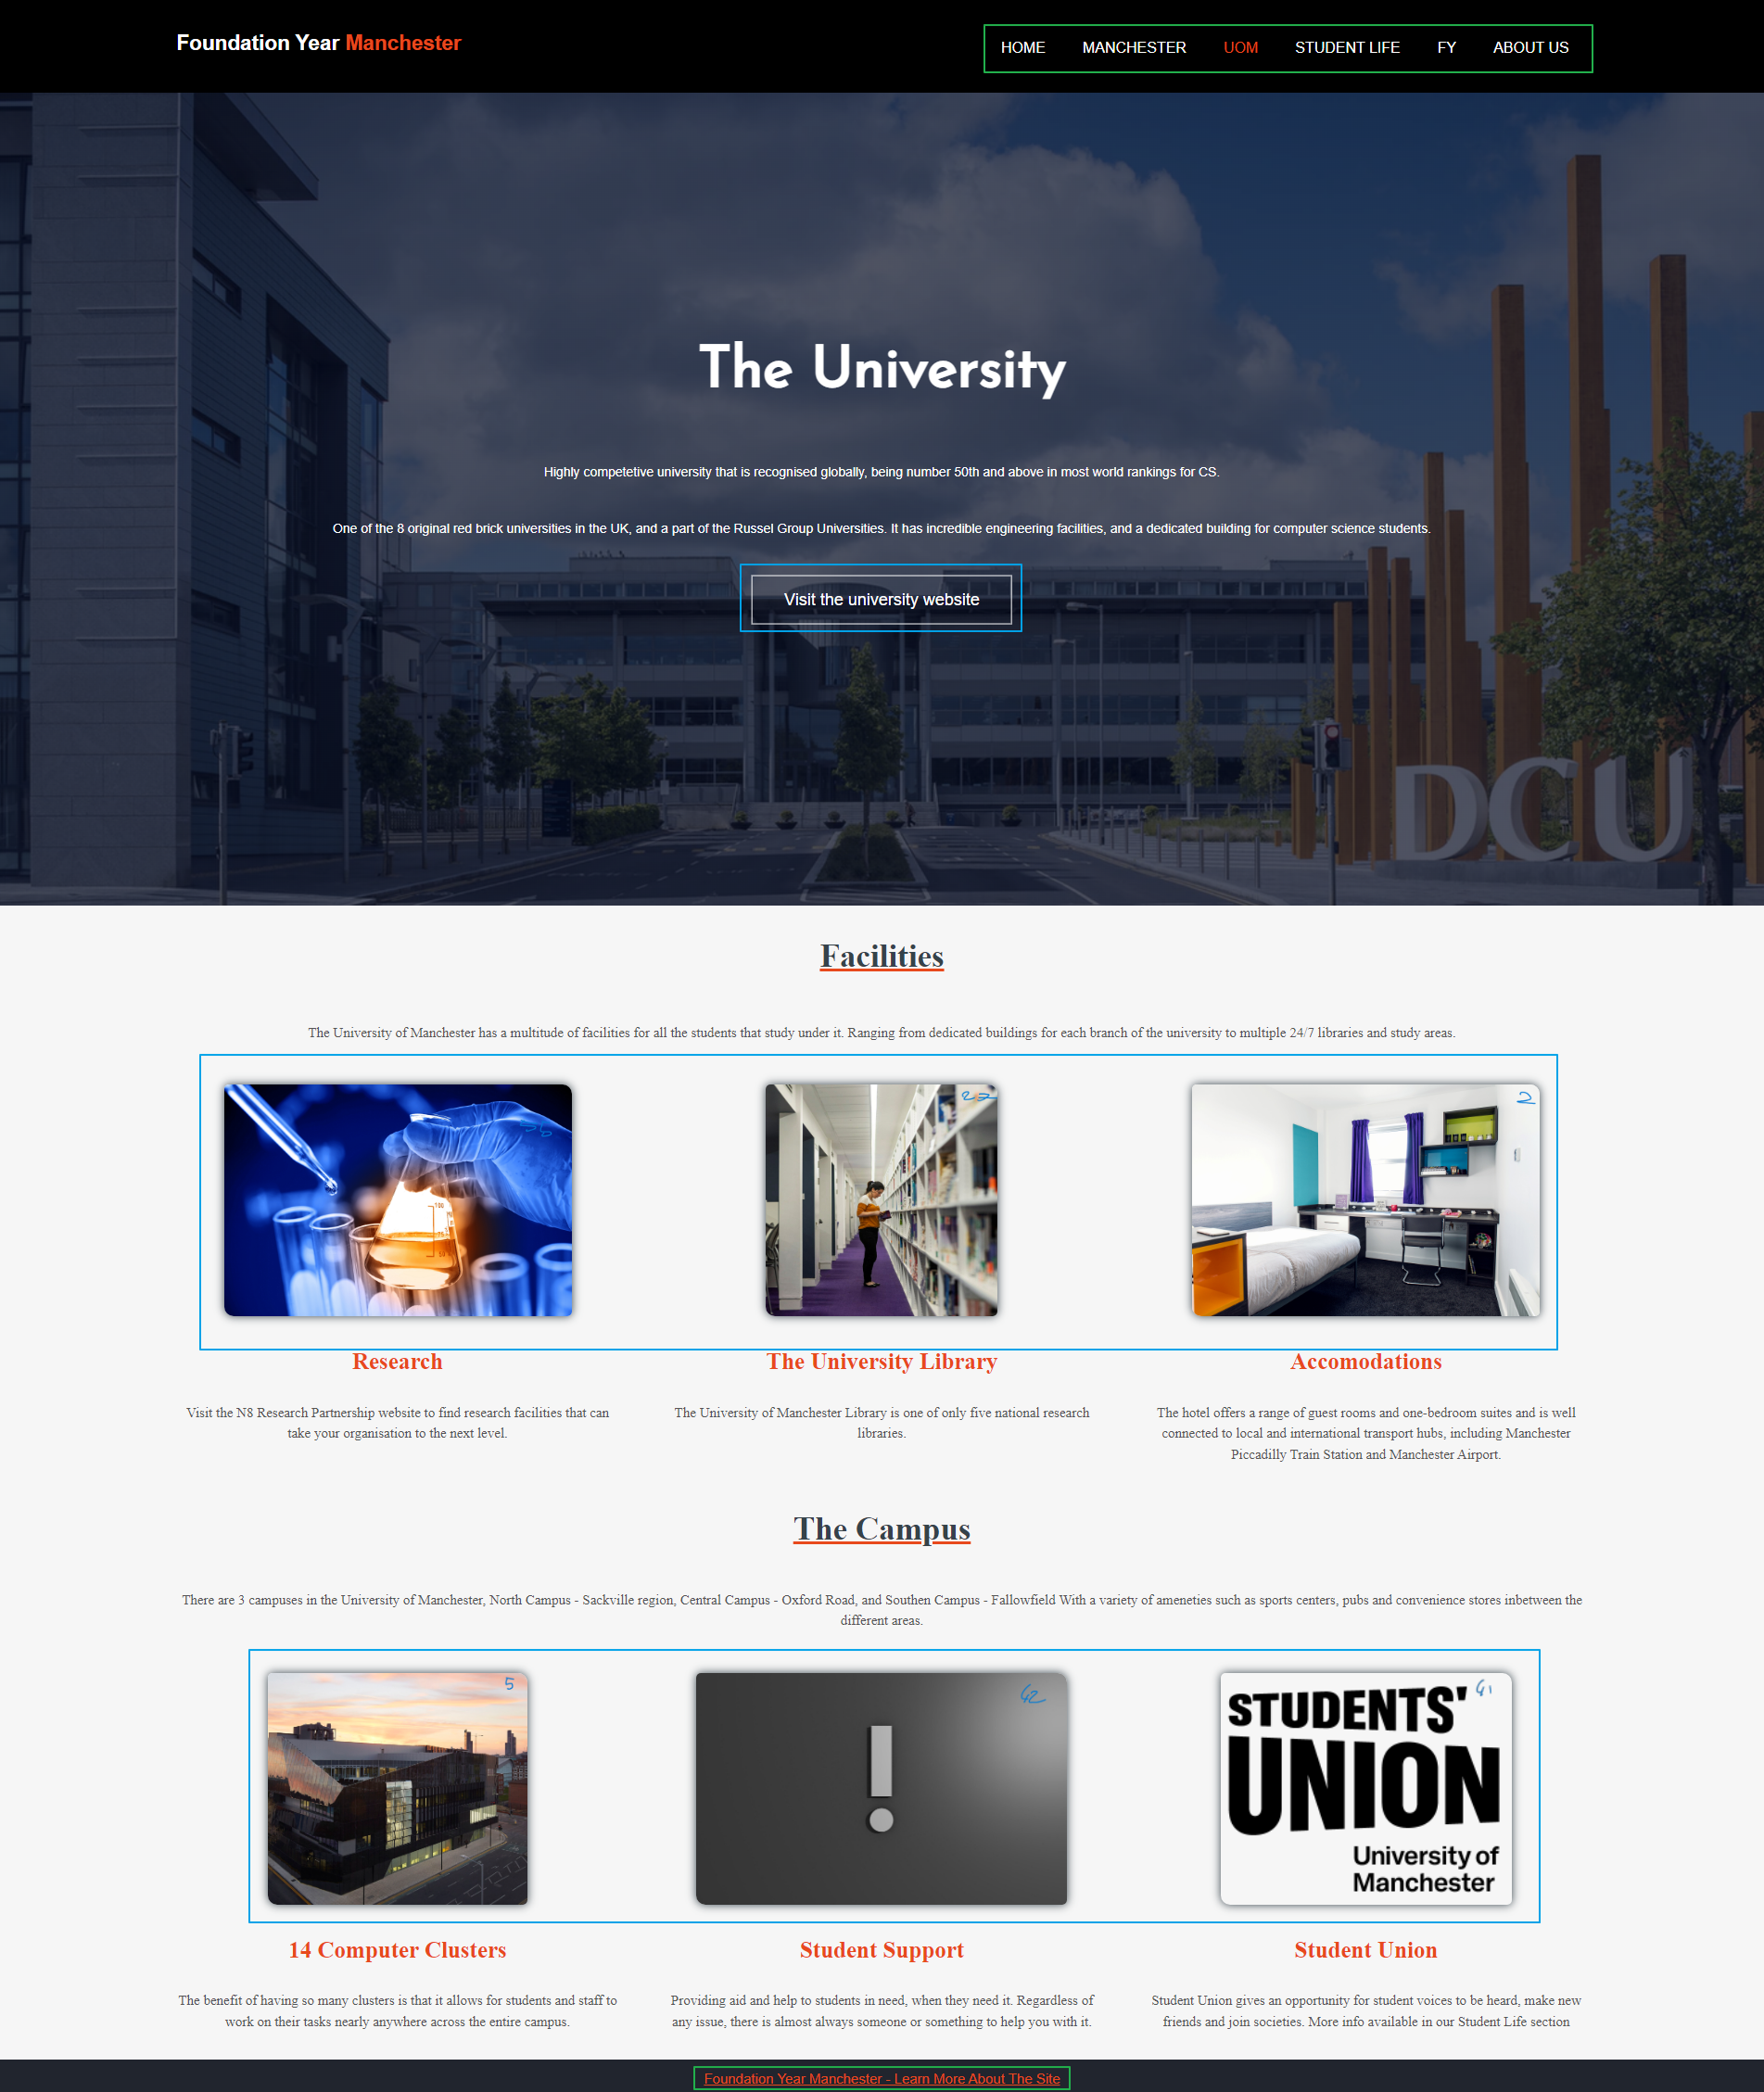

Figure : UoM section of the site with boxes to highlight sections

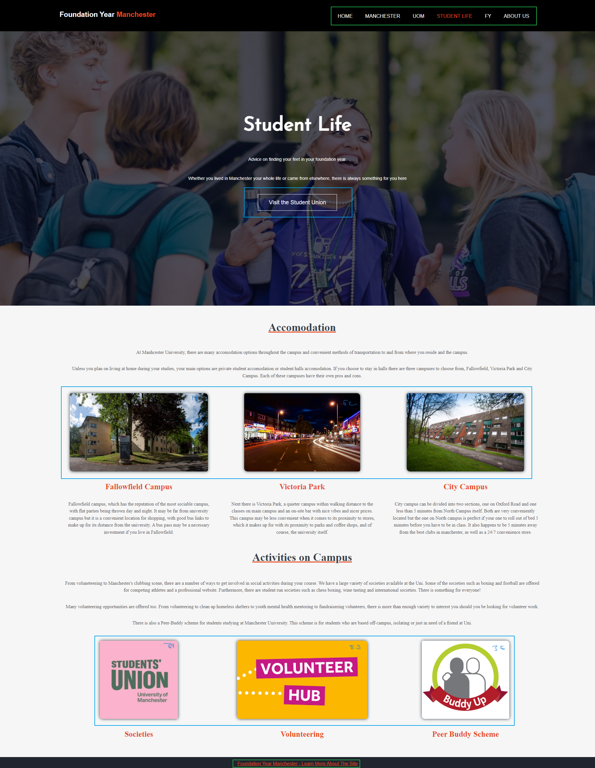

Figure : student life section with boxes to highlight different segments

Likewise to Figure 2, Figure 3 and Figure 4 have a layout that is split into 3 categories, title and banner, 1 segment of information followed by another segment. The blue boxes that encapsulate images and a button is used for external navigation, and the items encapsulated by the green box is used for internal and GitHub navigation.

# Navigation

## Navigation From Landing Page

Figure 1 contains 2 forms of navigation:

1. The yellow box that encapsulates the top navigation bar and the footer.
   * The navigation bar and footer are present in all the tabs. This is the main method of navigation between the different sections. The navigation bars are designed to lead into other tabs within the website, and the footer is linked to the GitHub repository the site was developed in.
2. The green box that encapsulates the [Visit Us] button and the 4 bubbles.

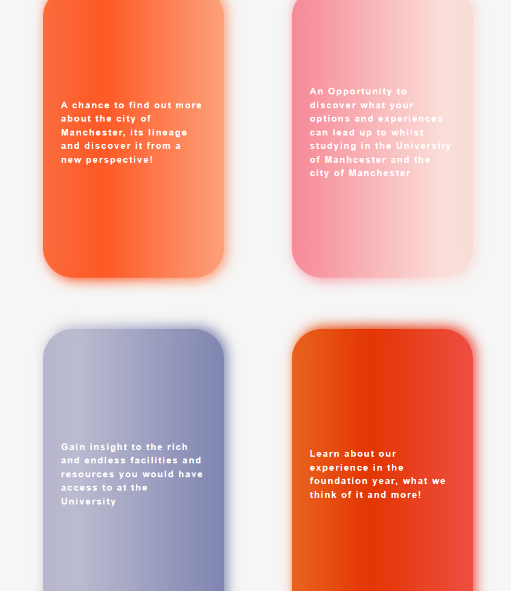

Figure : landing page bubbles under forced hover state

* + Similarly, to the top navigation bar, these buttons are designed to direct users into the different sections within the website. As seen in Figure 5, the bubbles provide basic information about the relevant section when hovered over.

## The top navigation bar (and footer)

The navigation from all the different pages within the website are via the same method. The top navigation bar that is boxed in green for Figure 2, Figure 3, Figure 4 and in yellow for Figure 1. The name of the tab that is currently being viewed will turn orange to indicate which one is being used.

The footer is also present at the bottom of each page, allowing access to the repository constantly throughout the site.

## Navigation to External Sites

An example of an image, button and link that is used to navigate on to external sites:

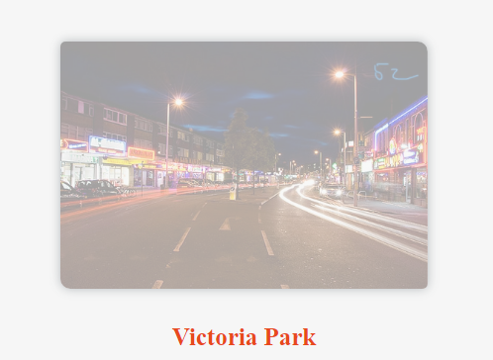

Figure : image hovering effect for external navigation

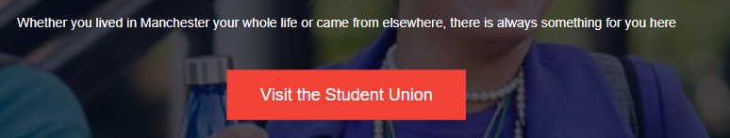

Figure : external navigation via button

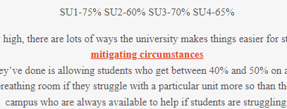

Figure : Link based external navigation example

The images that have an opaque white layer over them when hovering over are anchors that take users to external sites, as seen in Figure 6. This is done so that users can realise a significant change in style will engage them and incentivise them clicking on the image, to be redirected.

The button changing styles, Figure 7, and the links getting bold, Figure 8 is done for the same reason, to cause a change in state of the item, and to engage the user to click on it to be redirected.

# Visuals and information

## Visuals used

As mentioned in 2.2.3, images are used as a source of navigation, as well as providing basic visual information to users. The benefit of this approach is that it allows the site to convey information and give users an opportunity to explore topic in more depth if they wish to by engage with the button, as seen in Figure 6.

Some images retain their standard image properties, of just being an image. They do not contain links or animations and are there for the aesthetic and providing information via just the image. An example of this would be any of the banners that can be found in all the pages, behind the title and low-opacity black tint.

Other visuals used would include animations in the main landing page, on the hover effect. Figure 5’s bubbles have a gradient cycling and an under-glow effect added to them. There is no functional reason to it, but rather a visual stimulus

## Information used

The way the information needed and would be used was partially decided by the objectives and tasks for this project. The other major influence was what information students wished they had. These 2 factors directly influenced how the information was gathered and got implemented.

The method of getting the content was creating key headings, which branched off into subheadings,

i.e. Student Life 🡪 Accommodation, Clubbing, Societies

Using the subheadings, they became the topics to write about in their respective pages.

The content was gathered by:

* The experience of each group member – as to make it more authentic and genuine from a fellow student viewpoint
* The university website – as the information would be directly from the source and accurate
* Online forums and sites – to provide insight into the experiences and knowledge of others

Having these 3 gathering methods and using them in tandem with the branch layout, thorough and accurate information was put together to be placed on the website for use.

1. Website – Technical Aspect

# How does it work

The site works by using HTML5 code for the main content of the site, and CSS3 to influence the design and aesthetics.

## Landing page

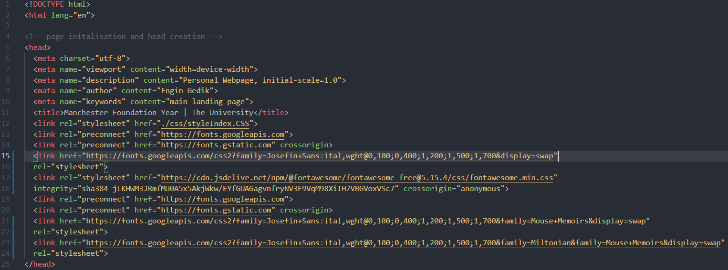

Figure : landing page initialisation html

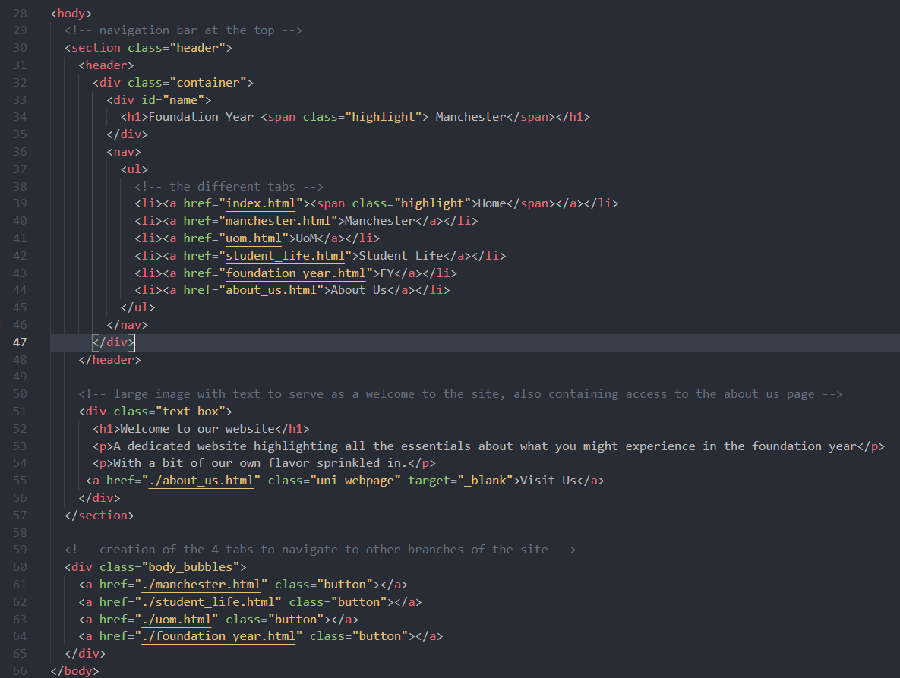

Figure : landing page body html

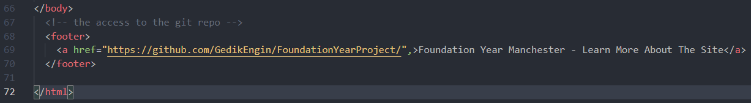

Figure : landing page footer html

Figure 9 initialises the webpage, links it to the correct CSS file and imports the fonts that are/were being used.

Figure 10 lines 28 to 48 create the top navigation bar and establish the title of the webpage. Lines 51 to 57 are responsible for creating the container that the banner and banner text are housed in. Lines 60 to 65 are responsible for the 4 bubbles that aid the navigation of the main web page.

Figure 11 contains the code for the footer that has an anchor tag that is responsible for leading users to the GitHub repository when clicked on.

## Manchester, UoM, Student life, FY

The four middle tabs are built using similar layout.

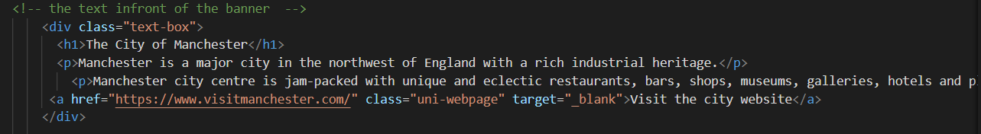

Figure : MANCHESTER PAGE MAIN IMAGE HTML

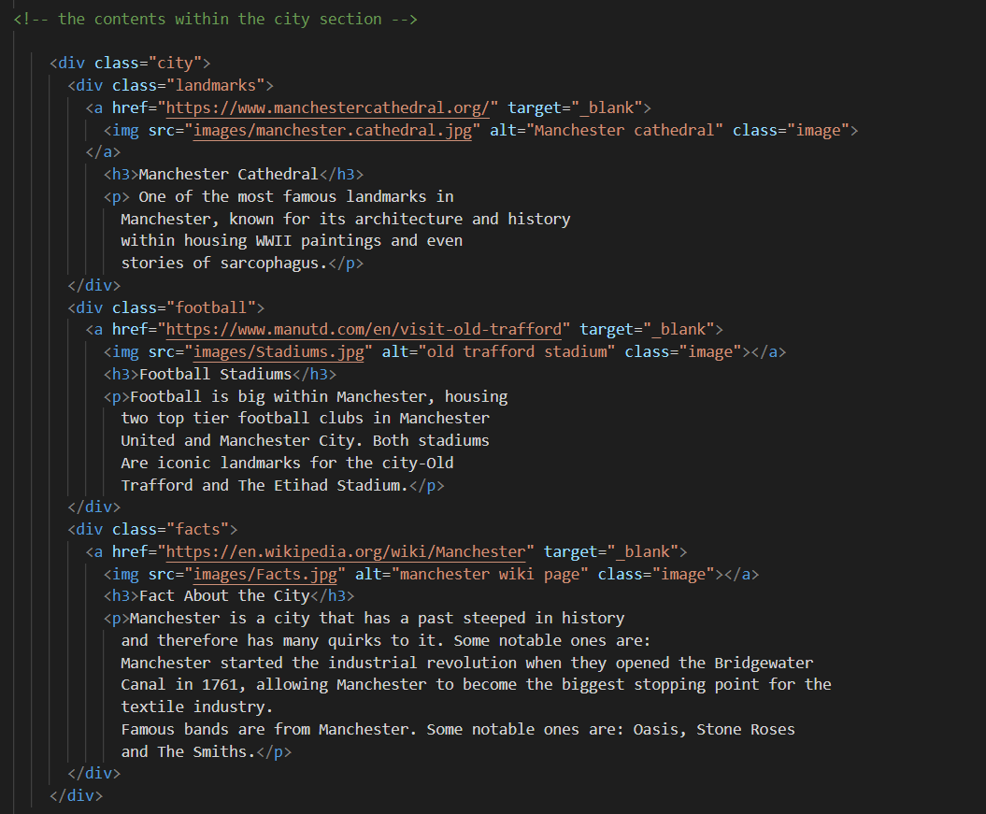

Figure :MANCHESTER PAGE BOXES HTML

As shown on the website, these four tabs use similar HTML design. This was decided as a group to keep the website tidy. The section title, fonts and hovers were decided independently.

All the images used are hyperlinks to navigate to respective webpages to find out more about the images and information below it.

The footer is the same for all tabs and can be seen in Figure 11.

## About Us

This is one the unique section on the website. The main background image is just as Figure 12.

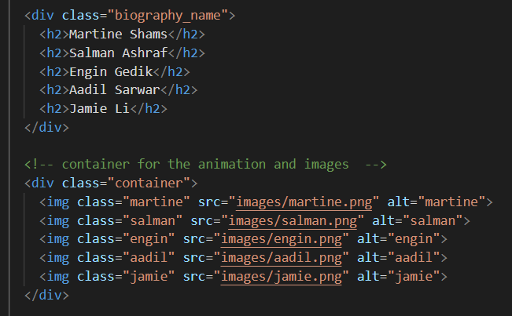

Figure : Biography section from 'about us' page

The highlight of this page is the introduction of all the member of the group. The class ‘container’ was used to add hover effect and animation.

# Tech used during creation

## Creation process

The structure of the website was initially created on Trello. This allowed for deadlines to be set, labels to be used to classify cards and highlight their priority. It also allowed for the division of sections and planning out of the content and what would be contained.

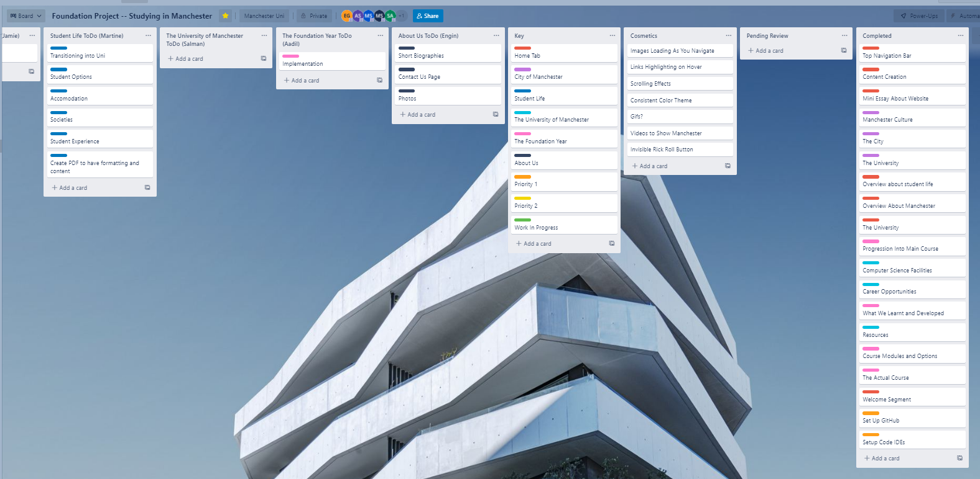

Figure : screenshot of the trello board midway through development

Once the basics of Trello was established, GitHub and Visual Studio Code was introduced into the group and project environment.

Using GitHub allowed for each member to work on the project at their own time and pace, which was important as a significant amount of the project was done over the easter break.

Visual Studio Code was used as that was the code editor that most of the group were familiar with, as well as having support for multiple extensions that were assistive in the creation of the site as well as GitHub.

These extensions include but not limited to:

* Prettier – Prettier
  + Modifies the visual appearance of the code to make it easier to understand and keep track of.
* vscode-pdf – tomoki 1207
  + Allows for the viewing of PDF files within the code editor, it is a quality-of-life measure that was beneficial when referring back to documents and plans previously made by the group and/or staff members
* Live Server – Ritwick Dey
  + Allowed for the changes made to the code to be viewed immediately
* Image Preview – Kiss Tamas
  + Allows for the images to be loaded in a mini fashion in the gutter, which helps as a guide to what image is being worked with
* Color Highlight – Sergii Naumov
  + A quality-of-life measure that was used in the CSS side of the project, helped in picking custom colours and viewing them without having to refresh the side
* Auto Rename Tag – Jun Han
  + An extension that changed the closing tag to match the opening tag and vice versa, which was beneficial when changing the structure of the code

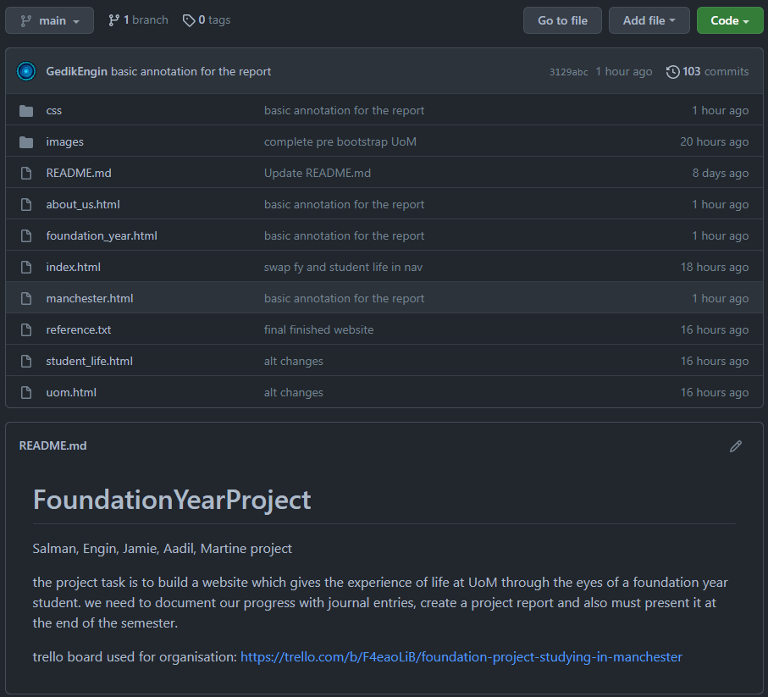

Figure : github repository

## Programming

The programming was done with HTML5 and CSS3, this was influenced solely by the task that was assigned and the objective of the site, to create a website detailing the Manchester Computer Science Foundation Year

# Creation process

## Pre-creation of site

The initial steps involved using Trello and pen and paper to create the rough plan of the site. Once the basic sections (Landing Page, Manchester, Student Life, UoM, FY, about us) were established, the subcategories within them were getting populated with relevant information.

The next steps were to install VS Code onto the personal machines of each group member, download the basic extensions and set up GitHub. GitHub was then tested and used with a series of test commits and initial commits to get familiar with the operations.

## Early creation stages

The early stages of the site included importing a website from one of the group members. The website was then heavily modified and purged of any old content and repurposed under the sections that it was meant to contain. The sections were divided between the group members based on their expertise and choice. After the delegation of tasks, the research stage took place, so that it would be easier to implement each section into the site as there would be a blueprint to follow.

The navigation bar, banner and footer were included in all pages as a compulsory style, and a colour theme of orange-white-black was established.

## Main creation phase

During the main creation phase, there was a significant number of stylistic changes taking place. Much of the content remained the same, however the styling and presentation underwent heavy changes multiple times. Each group member worked on their own section, either by experimenting with the built-in features or using online sources and modifying them to suit the specific style that they wanted to achieve.

## Final stages

During the final stages, all the styles were brought into a more streamlined version, where the font and tag styles were the same and uniform, 3/6 web pages had a near identical layout due to the information and layout they contained. Animations and other minor cosmetic stylings were added.

Bootstrap was attempted to be implemented, however the project was initially developed in a manner that would make it challenging to bring in Bootstrap into, so CSS was deemed as an adequate solution.

1. Conclusion

# Main conclusion

## Website brief

The websites’ key purpose was to provide information on the most important aspects of life at the University of Manchester. It covers the city, the university, the foundation year itself, and student life. We discussed our reasons for using HTML5, CSS3, and why we used VS code to write and edit our website. We noted that we used GitHub so that we were able to work collaboratively on the site so that everyone always had access to each-others work, this also helped with keeping track of the various versions of the site as it was being built.

## Website – Design aspect

This section overviews the design choices we made as a group. We described the layout of each page and gave reasons to why each page was constructed in that way; we highlighted some of the key features of the site such as the bubbles that are on the main landing page, found in Figure 1. We also noted a lot of other elements we used throughout the website such as the buttons that navigate to external sites, the top navigation bar and footer that were present in every page of the site.

## 4.1.3 Website – Technical aspect

The technical aspect covered the HTML and CSS that went into making the website that it seen by the user. It highlighted key features the “container” class used in the “About Us” page which was used to add the hover effects and animations. This section also covered the various tools we made use of during the creation of the site including Trello which we used to keep track of assigned tasks, GitHub which stored the code and various extensions from the VS code marketplace.

# Reflections

## Engin G. reflection

Overall, the project went very well. I was happy with the outcome of our website and the teams work and thoroughly enjoyed collaborating with them. If I had to pick an area to complain, it would be the limited time we had to work on the project. As we were creating the site, we discovered so many more potential ideas and templates we could use but it wouldn't be realistic to implement them into our current work, so it is a shame we did not have enough time to redesign and recreate the site properly. Personally, I feel as though I did exceptionally well. I challenged my own confidence, work ethic and knowledge of web development and I believe I came out on top as a more competent CS student. For next time, I would like to change how we got the project rolling, but that was only due to us discovering web development in depth as we created it, so for next time it should automatically resolve itself.

## Aadil S. reflection

The project went very well as a whole. The communication between group members and the organisation of the tasks was all very fluent and done efficiently within the time given for the project. The final website was also complete to a high standard, and we managed to keep the theme consistent across all the pages. One thing which could have been better was if we were given more time to conduct the project tasks as there were many ideas we had as a group which could not be implemented effectively in the time we had. My personal input into the project was detailed and concise. I got all the information I needed for my allocated sections and put it together in a neat and professional way. The research for my sections has given me a better understanding of what it is like to be a computer scientist and has further increased my resolve to become one in the future. One thing I would change is the amount of research I do before the project work officially starts, this would give me a better baseline when the project begins and would allow me more time to implement various features into my work because I already have an idea about how to go about it.

## Jamie L. reflection

The project was a success for the whole team. Everyone from the team added to the project using their skills and the level of contribution from the entire group was amazing. Every meeting we had, everyone was present and whenever we agreed to do specific tasks, there would be no complaints, and everyone would do their own part to the best of their ability. Due to this, the final product of the website was a very high standard website and managed to convey everyone's work. However, the timing of the project felt a bit off. With deadlines after Easter and coursework's, it felt like we didn't have time to implement some of the things we wanted to within the project. My input within the project was to make my part of the website look professional and complete with research and images of the city. As my part was on the city of Manchester, it allowed me to explore some famous parts of the city and a general overview of the culture within the city. Something I would change would be the level of web development resources given to us for the project by the unit. It felt like the web development (HTML, CSS and Bootstrap) section was bland and didn't give much help to students who hadn't already experienced it.

## Martine S. reflection

I think that this project went really well for all of us. We all used our relevant skills to add our own touches to the website and allocated the individual tasks accordingly. From learning how to communicate with each other with a different dynamic than before, seeing as a new member joined our group. I personally learnt so much from my teammates, from HTML to CSS tips and tricks and organisational skills. I am very glad to have had this experience and to have learnt so much from it. This will definitely serve me well in first year. We were not initially on the same page as to what our content was going to specifically focus on. I personally felt happy with what I did for this project. One of my contributions to the website was figuring out the problem with the CSS code that didn’t let us write more than one line in each paragraph. That really helped the format with my section of the website in particular. What I would change is that there was not enough time given or adequate resources for HTML and CSS coding for a website, especially considering that we’ve had many other deadlines at the same time.

## Salman A. reflection

Regardless of the grades we get, this project was a great success for me. Everything went according to the plan. The teamwork was amazing, everyone made a decent contribution and was present for all the meetings. Everybody completed their given tasks within decided deadlines. The website was completed a couple of weeks before the deadline, giving everyone enough time to focus on the report. However, some weeks after the Easter break was very busy with deadlines and coursework and due to the lack of available time, we could not give enough time to Latex. I personally made useful contributions to the website and used my previous knowledge of web development to improve the design. I also had input to decide on the report content and images used to refer back to the website. At the end of the day, the project was a huge success, however, next time I would want the better resources to be given to us to learn about web development. There was not much help provided to the student on how to learn web development. Also, I would want the project to start earlier and give us more time to manage other modules too.

## Group reflection

As a group, we feel that the project was a success. We all managed to come together and complete the foundation year project, to what we believe is a high standard, on top of all the other units each of us are studying. We all agree that the team collaboration and feedback we attained from each other throughout the project was constructive and effective for the time we had. Although we have all mentioned it in our individual reflections, it bares repeating that we all believe that there was not enough time given to us to carry out the project to our fullest potential; if more time was given, we could have implemented more of our ideas into our website and given it an overall greater polish. We all pitched in and helped where it was needed most and never let any other member in the group become flooded in work. To sum up, we all feel as though the project went well and if we were to change anything, it would be the amount of time we were given to carry it out.

# Main things learnt as a group

The following is what we have agreed we have learnt during the foundation year project:

* How to work as a team to meet a deadline
* How to interact with each other as a team to complete tasks
* How to assign tasks equally
* How to adjust for group members who cannot reach a deadline
* How to fit our personal schedules around group meetings
* How to adjust for unexpected changes to a plan
* Other valuable team building skills